TITLE: Exploring The Psychometric Properties Of The Environmental Screening Questionnaire (ESQ) Using A Network Approach

AUTHORS: Rodrigo Leão F. do Nascimentoᵃᵇ*, Kimberly Murphyᵇ, Luis Anunciaçãoᵃᵇ, J. Landeira-Fernandezᵃ, Jane Squiresᵇ

AFFILIATIONS:
ᵃ Department of Psychology, Pontifical Catholic University of Rio de Janeiro (PUC-Rio), Rio de Janeiro, Brazil.
ᵇ Center on Human Development, University of Oregon, Eugene, Oregon.

ORCID/ EMAIL:
Rodrigo Leão F. do Nascimento: https://orcid.org/0000-0001-6443-229X, rodrigoleaopsi@gmail.com, + 55 21 971727977, * Corresponding Author.
Kimberly Murphy: https://orcid.org/0009-0003-3616-2212, kamurphy@uoregon.edu.
Luis Anunciação: https://orcid.org/0000-0001-5303-5782, luisfca@puc-rio.br.
J. Landeira-Fernandez: https://orcid.org/0000-0002-8395-8008, landeira@puc-rio.br.
Jane Squires: https://orcid.org/0000-0002-3299-8704, jsquires@uoregon.edu.

ACKNOWLEDGMENTS: To the National Council for Scientific and Technological Development (CNPq).

Abstract
Environmental risk factors play an important role in child development, yet few tools are available to assess these risks during the preschool years. This study examined the psychometric structure of the Environmental Screening Questionnaire (ESQ) using a network analysis approach. Data were collected from 22,391 parents or caregivers of American children aged 1 to 83 months, of whom 55.6% were male. A network model based on the Ising algorithm was estimated. Centrality indices and community detection were performed, revealing six clusters. The highest mean score was observed in the Economics and Finance area (M = 8.07, SD = 10.27). The item related to access to support programs, such as WIC, SNAP, and Medicaid, showed the highest centrality, appearing as the most influential node within the network. Overall, the findings offer initial support for the ESQ as a psychometrically robust instrument for evaluating contextual risk factors associated with early childhood development.

Keywords
Adverse Childhood Experiences; Child development; Network Analysis; Reduced inequalities; Social Determinants of Health.

Introduction
The adverse childhood experiences (ACEs) seminal study posited that severe adverse childhood conditions were associated with compromising aspects in an adult’s life (Lazar et al., 1982). These findings were consistently reaffirmed over the two decades after the original study (Squires & Bricker, 2020). The literature in the field has indicated that ACEs are traumatic events that happen during childhood, including but not limited to experiencing violence, abuse, or neglect (Bhutta et al., 2023; Lazar et al., 1982; Squires & Bricker, 2020). Subsequently, an increased research focus has turned to the development of measures able to assess the impact of ACEs on child development (Squires & Bricker, 2020).
A recent review conferred an additional scope on the extent of the detrimental effects of ACEs on a subject’s lifetime (Bhutta et al., 2023). The authors suggest that mild to severe adverse exposure levels occurring even in the prenatal period of life are associated with compromised health outcomes throughout a lifespan. They argue that in addition to the most well-known factors established in ACEs studies (e.g. poverty, sexual abuse), it is important to consider the emerging events of armed conflicts, climate change, environmental degradation, and pandemic crises. In line with these risk factors, a study that focused on the impact of the COVID-19 pandemic on maternal mental health, parental practices, and early childhood development found evidence suggesting that the latter was affected by families’ financial burden and loss of access to health services (Penna et al., 2023). These contextual factors are related to stress-related risks for typical child development outcomes.
Due to its importance in subsequent life stages, preventing or mitigating the consequences of stressful events in child neurodevelopment is a global need (World Health Organization, 2023), especially in the early childhood years when a child’s brain is highly sensitive to this exposure (Bhutta et al., 2023; El Khawli et al., 2018; Lupien et al., 2001). On an individual level, early stress exposure is associated with alterations in different brain networks and areas (e.g. amygdala centered resting-state functional connectivity, ventrolateral Prefrontal Cortex, etc.), neurocognitive functions (e.g. memory, executive functions), and capabilities (e.g. reappraisal) (El Khawli et al., 2018; Lupien et al., 2001). A meta-analysis study found evidence of the predisposition of these subjects towards the occurrence of future mental health problems (e.g. depression) (Kraaijenvanger et al., 2020). The ubiquitous presence of stress in such studies has led researchers to investigate its associations with child development alterations using different measures (e.g. cortisol levels, maltreatment, socioeconomic status) (Bhutta et al., 2023). According to these authors there is an overlap between people experiencing stressful environmental factors and those living under ACEs circumstances. Thus, not only biodevelopmental markers must be measured but also additional contextual risk factors.
For optimal developmental outcomes, the investigation of social determinants of health (SDOH) is vital. The World Health Organization (2013) defined SDOH as “the circumstances in which people are born, grow up, live, work and age, and the systems put in place to deal with illness. These circumstances are in turn shaped by a wider set of forces: economics, social policies, and politics.” SDOH assessment and monitoring are part of a global effort driven by the WHO towards the mitigation of the effects derived from inequalities within different factors, including ‘early life and education’ (World Health Organization, 2023). The development of SDOH environmental screening measures for the early childhood population should: (1) focus on efforts implemented by WHO; (2) aid in identifying broadly contextual factors associated with the above-mentioned detrimental effects on children’s development and wellbeing; (3) and finally, contribute to the development of knowledge about early childhood development and risk.
Despite its undoubted relevance, the measurement of the SDOH in early childhood has not received adequate focus (Sokol et al., 2019). These authors found evidence of robust psychometric properties for eleven measures, but only four of them addressed the early childhood area. In the face of this scarcity of measures targeting SDOH in early childhood, the Environment Screening Questionnaire (Squires & Bricker, 2020, 2007) was developed to identify environmental risk factors that affect children’s subsequent lives. The ESQ addresses environmental risk factors in six areas: 1) Education and Employment; 2) Housing; 3) Child and Family Health; 4) Economics and Finances; 5) Family Life; and 6) Community. When used with developmental screening measures, these tools offer a comprehensive range of information, enabling the early identification of children who may require further in-depth assessment and support.
A previous study explored the ESQ initial psychometric properties including its utility (Moxley-South et al., 2015). A total of 324 caregivers with young children participated in completing print forms (N = 72) and online (N = 252) forms. Among the main results, preliminary evidence of concurrent validity was obtained comparing the ESQ and the Parenting Stress Index-Short Form (PSI-SF; Abdin, 1995). Results indicated that online caregivers with higher ESQ scores (i.e., more risk factors) tended to have slightly higher parenting stress. Other significant correlations were found between the ESQ score and the Ages & Stages Questionnaire: Social-Emotional (ASQ:SE; Squires et al., 2002, 2015) scores for the online caregiver sample at 6 months, and 48 months. In addition, 82% of agency professionals indicated they planned to use this measure in future situations and reported that the ESQ was useful for identifying family’s strengths and needs, and to monitor their status. More recently, another study investigated the patterns of association between scores from both Brigance and the ASQ:SE-2 with ESQ scores. The authors highlighted that, among the main findings, after controlling for sex and age, Education-Employment concerns were significant predictors of lower Brigance scores, whereas the Community and Child and Family Health areas were significant predictors of ASQ:SE-2 scores (Farkouh et al., 2025).
An emergent field of research known as network psychometrics approach has been adopted to add to current knowledge of the ESQ. This field of research on psychometrics posits that nodes of a network reinforce each other causing its activation and stability (Isvoranu et al., 2022). Network analysis has been applied in recent studies to different areas such as psychopathology (Borsboom & Cramer, 2013; Cai et al., 2024) and cognition (van der Maas et al., 2017) among others (Borsboom et al., 2021)
That said, this study aims to explore the psychometric structure of the ESQ using a network analysis approach. This investigation will provide insights not only into structure but also into the conditions and factors that might affect a child's development.
Material and methods
Participants and Procedures
This study was part of a project that assessed early childhood development using parent-completed assessments. The data collection started in 2019, online (N = 30,902). This data collection procedure is often used in epidemiological settings due to its large reach (Tyrer & Heyman, 2016). For the larger study, respondents completed the ASQ-3, ASQ:SE-2, PSI-SF, and ESQ. The target of this study was on the ESQ completed by a subsample of parents/caregivers (N = 22,391).
Sample Characteristics
Parents or caregivers completed the ESQ for 22,391 children. The child's age ranged from 1 to 83 months (approximately 7 years old). Males made up more than half (55.6%) of our sample. The family income range varied across categories; the majority of the respondent’s education level was 4-year college or above (44.2%). Finally, a total of 14,116 (61%) of the respondents were White. Table 1 shows the demographic characteristics of the sample.
INSERT TABLE 1 HERE
Ethical Issues
All participants were informed of the goals of this study and gave informed consent. The approval for the project entitled ‘XXXX’ approval was obtained before the start of the study.
Measure
Environmental Screening Questionnaire (ESQ)
The ESQ was developed by Squires & Bricker (2007; 2015) to assess areas known to impact the welfare of young children. It was developed to help in the identification of specific information in order to assist with targeting family needs. The ESQ assesses a total of 6 areas: 1) Education and Employment; 2) Housing; 3) Child and Family Health; 4) Economics and Financials; 5) Family Life; and 6) Community. Each area has five related questions, in which caregivers use a ‘yes-no’ option. They also mark if the question represents a concern. Regarding the score, a `yes` response receives 10 points, while a `no` response receives 0 points. If the box ‘concerned’ is checked for an item, an additional 5 points are added to that item. Thus, all areas range within 0-75 points, and higher scores indicate more risk factors in a child’s life that may affect caregivers’ ability to meet their children’s needs. Areas of greatest risk and concern to parents can be targeted for intervention. Examples from the ESQ appear in supplementary table 1.
Statistical Plan
The ESQ items fall in six areas, which were totaled separately for this analysis. Descriptive analyses of the ESQ were conducted by checking area distributions using range, mean, and standard deviation. In addition to the previous analyses, a one-way repeated measure ANOVA was computed to check for significant differences within the groups followed by post-hoc tests.
We estimated a network model to explore the internal structure of the ESQ, including its central measures and communities. Due to the binary nature of all items, we followed the procedures recommended by Isvoranu et al. (2022) for estimating networks with binary non-normally distributed data. The first step was selecting the function `binarize` from the R package `bootnet`, which was used to recode the variables to 0 or 1. This step was necessary to allow the R package `IsingFit` to function adequately. Secondly, the network model was estimated using the eLasso procedure which combines l1-regularized logistic regression with model selection based on the Extended Bayesian Information Criterion (EBIC) on the Ising model (Van Borkulo et al., 2014). This regularization procedure sets two types of parameters: the tuning parameter lambda (λ) and the hyperparameter gamma (γ). The tuning parameter lambda (λ) reduces spurious edges in the network by amplifying the number of true edges. The λ value choosing is in some instances still under debate but the default value (λ = 0.50) has been consistently suggested due to its good results in simulation studies (Epskamp & Fried, 2018), therefore we opted to maintain it. On the other hand, the hyperparameter gamma (γ) controls how much the EBIC prefers simpler models. The Ising models usually adopt the value (γ = 0.25) due to the type of data (Epskamp & Fried, 2018).
The degree of importance of each node in the network is investigated with centrality measures, and we investigated the node strength, closeness, and betweenness of the network model. The node strength includes the sum of absolute edge weights connected to each node, which provides a direct measure of the strength of associations among the node with other nodes in the network; while the closeness is computed by taking the inverse of the sum of all distances from one node to all other nodes, which informs how much the node is distant from other nodes of the network. Finally, betweenness is computed by investigating how many shortest paths go through a node of interest, which informs how much the node provides access to other nodes of the network (Isvoranu et al., 2022).
Lastly, the R Package `EGAnet` was used to detect the number of communities in the network. This analysis is especially relevant to exploring new structures in complex networks (Golino & Epskamp, 2017). We opted for using the Spinglass algorithm to reveal how many clusters would be found in the network model. All analyses were performed using R Studio packages `bootnet`, `qgraph`, `IsingFit`, and `EGAnet`. Data are available at https://osf.io/XXXX.
Results
The format of the distribution of the ESQ areas was asymmetric, indicating that lower results (i.e. fewer risk factors) were more frequently present in the data. Table 2 describes the descriptive statistics of the ESQ, including its range, mean, and standard deviation.
INSERT TABLE 2 HERE
The mean results of the six ESQ areas were significantly different (F(5, 111950) = 2538.6, p < .001, η² = .063). A post-hoc test demonstrated that the only non-significant comparison was between Education and Employment and Child and Family Health (p = .584). Overall, the highest mean was obtained in the Economics and Finances area (8.07 ± 10.27), higher than Education and Employment (7.45 ± 8.70), Child and Family Health (7.33 ± 9.07), Housing (1.79 ± 5.31), Family Life (4.51 ± 7.70), and Community (5.23 ± 8.40).
Network Analyses
Figure 1 shows the network analysis of the ESQ items using the Ising model. The weighted matrix was composed of 463 association pairs. From which, 275 (59.4%) significant correlations were different from zero. Among the 275 significant associations achieved, only 12 (2.6%) were significantly negative, and 224 (97.4%) were positive. Supplementary table 2 highlights items with the strongest positive associations found in our results.
INSERT FIGURE 1 HERE
Centrality Analysis
The inspection of the centrality measures appears in Figure 2. These measures provide information about the strength of the direct association of one node with others (node strength), an indirect measure related to the distance of one node with others (closeness), and about how much one node intermediates the path to other nodes (betweenness). This analysis revealed that the node ‘Do you have regular transportation?’ presented the highest degree of closeness and betweenness compared to the other nodes, and the second highest strength degree. It was surpassed only by the node ‘Do you currently use support programs such as WIC, food stamps (SNAP), or Medicaid?’ which showed a strength degree slightly superior. The nodes ‘Do you have a spouse/partner who lives with you most of the time?’ and ‘Do you currently use support programs such as WIC, food stamps (SNAP), or Medicaid?’ achieved the second and third highest levels of closeness compared to the rest of the network. Thus, these three nodes are possibly the most important in the network. In addition, ‘Do you have regular transportation?’, ‘Do you currently use support programs such as WIC, food stamps (SNAP), or Medicaid?’, and ‘Does anyone in your home have problems with depression, anger, or anxiety?’ showed the highest betweenness levels, which means that it is the shortest path among pairs of nodes.
INSERT FIGURE 2 HERE
Community Structure of the ESQ Network
The results of the community detection analysis performed using the Spinglass algorithm revealed six clusters of items, see Figure 3. The yellow cluster is composed of nine nodes from all areas except the areas Housing and Education and Employment. Most of its nodes were from the Community area. The blue cluster is formed by five nodes three from the Child of Family Health area, and the rest of the Education and Employment area. The green cluster groups all nodes from the Housing area, except the nodes ‘Have you or your child/children witnessed violence in your home or neighborhood?’ and ‘Is your housing in below-average condition?’ that pertains to the orange cluster. In addition to these nodes, this cluster is composed of two nodes from the Family Life area and the node ‘Does anyone in your home have alcohol or drug problems?’. The purple cluster counts with three nodes in the Economics and Finances area. Finally, the red cluster is composed of nodes from the Education and Employment area in addition to the nodes ‘Do you have a spouse/partner who lives with you most of the time?’ and ‘Do you currently use support programs such as WIC, food stamps (SNAP), or Medicaid?’.
INSERT FIGURE 3 HERE
Discussion
This study aimed to investigate the preliminary psychometric properties of the ESQ. To achieve this goal, a network analysis was performed with a sample composed of 22,391 children, whose ages ranged from 1 to 83 months (approximately 7 years old). This distribution is in line with the statistics extracted from the U.S. Census Bureau population data related to the years 2019 to 2023 (U.S. Census Bureau, 2023). The ESQ areas scores were asymmetric, with the Economics and Finances area achieving the greatest mean (M = 8.07, SD = 10.27), while the Housing area presented the lowest mean (M = 1.79, SD = 5.35). The network analysis found 235 significant correlations which were the majority positive (N = 224), with few negative (N = 11). The inspection of the central measures showed that the item Economics and Finances 3 (‘Do you currently use support programs such as WIC, food stamps (SNAP), or Medicaid?’) presented the greatest strength degree. This item was followed by the item Community 5 (‘Do you have regular transportation?’) which exhibited the highest degree of closeness and betweenness. An additional community detection analysis grouped all items into six different clusters.
When exploring the mean score values for each ESQ area, significant differences were found among them (p < 0.001, η² = .063). A post-hoc test showed a non-significant comparison between Education and Employment and Child and Family Health (p = 0.584). The greatest result was obtained in the Economics and Finances area (8.07 ± 10.27), which surpassed Education and Employment (7.45 ± 8.70), Child and Family Health (7.33 ± 9.07), Community (5.23 ± 8.40), Family Life (4.51 ± 7.70), and Housing (1.79 ± 5.31). Within the Economics and Finances area, the item ‘Do you currently use support programs such as WIC, food stamps (SNAP), or Medicaid?’ had the greatest mean (3.75 ± 4.84) and was the second most reported problem (37%) among all ESQ items. Following this item, ‘Do you have credit problems?’ (2.15 ± 4.11), and ‘Does your income cover your monthly expenses?’ (1.24 ± 3.29) were consecutively the second and third items more endorsed in this area. Altogether, these values could be partially influenced by different patterns of consumers’ credit card usage compared to before and during the pandemic crisis in the United States of America, as suggested in the report named ‘Credit Cards` (U.S. Government Accountability Office, 2023). This report describes how pandemic assistance likely helped to reduce balances in the sample studied. However, higher interest rates, lower credit limits, and longer-carried balances were more prevalent in zip codes with a majority of Black or African American or Hispanic or Latino residents than White zip codes.
The most prevalent parent concern among all the items was found in the ‘Child and Family Health’ area concerning mental health, ‘Does anyone in your home have problems with depression, anger, or anxiety?’ (4.07 ± 4.91, 41% of the participants). Different sources suggest that mental health problems are increasing worldwide, especially after the pandemic outbreak (Mucci et al., 2023; Wolf & Schmitz, 2023). In addition to this, the second most endorsed item in this area was, ‘Do you have a child with a learning or behavior problem?’ (1.42 ± 3.49). The relationship between families' untreated mental health concerns and children`s learning or behavior problems is well-established in the field (Lazar et al., 1982). Within the Housing area the item most endorsed was ‘Do you need to live with friends or family not by choice?’ (0.65 ± 2.47), while ‘Do you consider yourself homeless?’ (0.08 ± 0.91) obtained the lowest means. In addition to slight increases in income levels due to pandemic assistance policies, these results were expected considering the sampling procedures adopted which required majority access to an online website.
The ESQ areas (e.g. housing, community) can be seen as dynamically integrated, which reinforces the importance of the network approach. Thus, for the estimation of the ESQ network structure we used the eLasso procedure which was suggested as useful for explorative model search (Borsboom, 2022). Among the 275 significant correlations achieved, 97.4% (N = 263) were significantly positive, while only 2.4% (N = 12) were significantly negative.
Among the positive correlations, the strongest associations found were between the nodes `Do you have frequent spouse/partner conflicts?`, `Are you in a relationship in which you have been physically hurt, felt threatened, or been controlled by someone else?`, and `Have you or your child/children witnessed violence in your home or neighborhood?`. Altogether, these results seem to suggest the presence of increased risk related to familial conflicts in our sample. According to the study review conducted during the pandemic period (Penna et al., 2023), even with additional barriers to assessing intimate partner violence (IPV), the results pointed to increased rates of this and child abuse. One of the factors suggested by the authors to explain this finding was related to the need of victims to cohabitate with aggressors at that time. Other sets of risk factors with positive correlations were job concerns driven by language barriers; instability regarding accommodation and housing; lack of social support and access to childcare; unavailability of material resources (e.g. phone, transportation); lack of access to health insurance; and finally, economic difficulties related to basic needs (e.g. monthly expenses, food).
According to Isvoranu et al. (2022), centrality measures are usually computed to estimate the position and role of a node in a network. The nodes ‘Do you currently use support programs such as WIC, food stamps (SNAP), or Medicaid?’ and ‘Do you have regular transportation?’ showed the highest strength degree among all nodes. This measure reveals the importance of those nodes to the network, which points to the content addressed by these items. The use of support programs to provide basic needs and difficulties obtaining regular transportation are issues really central to any subject’s life. The nodes ‘Do you have regular transportation?’, ‘Do you have a spouse/partner who lives with you most of the time?’ and ‘Do you currently use support programs such as WIC, food stamps (SNAP), or Medicaid?’ achieved the first, second and third highest levels of closeness compared to the rest of the network. The high closeness indicates that node reaches all other nodes relatively fast. Again, transportation and access to support programs show up as items more prone to affect the other nodes. In addition to them, the marriage status appears influencing indirectly other nodes of the network. Marriage status has been considered a protective factor to different life outcomes, including life expectation (Tatangelo et al., 2017). Finally, the nodes ‘Do you have regular transportation?’, ‘Do you currently use support programs such as WIC, food stamps (SNAP), or Medicaid?’ and ‘Does anyone in your home have problems with depression, anger, or anxiety?’ showed the highest betweenness levels, which means that they tend to connect clusters of nodes together. In addition to the previous items mentioned, mental health concerns influence all other items in an indirect way.
The results of the community detection analysis revealed the presence of 6 clusters. The main goal of this analysis is to verify highly connected clusters that exhibit greater connectivity within than between clusters (Golino & Epskamp, 2017). As expected, all nodes were grouped forming different clusters (or communities). The inspection of each cluster showed how the different nodes of each ESQ area were associated with another one. In general, it is possible to see how different aspects of each node are directly or indirectly influencing the structure of the ESQ network.
Despite the added evidence on the ESQ psychometric properties, this study presented some limitations. First, the collection procedure required access to the internet. Thus, people facing severe housing issues or living in poverty might not have participated. Second, our data covered a period of time pre and during COVID-19 pandemic, which could, on one hand, influence the endorsement of some items. But as noted earlier, the likelihood of events like this is predicted in the future (Bhutta et al., 2023).
This study is of sum importance to the field. In face of the scarcity of instruments to cover environmental aspects that affect child development, the search of sources of evidence for new measures able to address this entangled network of contextual risk factors is important to the community. Future studies must focus on reliability, concurrent validity, and utility aspects of the ESQ. The ESQ has presented satisfactory preliminary psychometric properties using a network analysis. This analysis indicated the relevant information about different roles displayed by items. Cumulative evidence suggests that a 6-cluster structure is well fitted for the data and our results are partially related to the ESQ theoretical areas: education and employment, housing, child and family health, economics and financials, family life, and community.
Acknowledgments: To the XXX.
Funding details: This work was supported by the [Funding Agency #1] XXXX under Grant Call No. XXXX and XXXX.
Declaration of Interest Statement: The authors report there are no competing interests to declare.
Data Availability Statement: The authors confirm that the data supporting the findings of this study are available within the article.
Declaration of generative AI use: The authors report generative AI was not used in their research or preparation of this manuscript.

References
Abdin, R. R. (1995). Parenting Stress Index, Third Edition: Professional Manual (Third Edition). Psychological Assessment Resources, Inc.
Bhutta, Z. A., Bhavnani, S., Betancourt, T. S., Tomlinson, M., & Patel, V. (2023). Adverse childhood experiences and lifelong health. Nature Medicine 2023 29:7, 29(7), 1639–1648. https://doi.org/10.1038/s41591-023-02426-0
Borsboom, D. (2022). Possible Futures for Network Psychometrics. Psychometrika, 87(1), 253–265. https://doi.org/10.1007/S11336-022-09851-Z/METRICS
Borsboom, D., & Cramer, A. O. J. (2013). Network analysis: an integrative approach to the structure of psychopathology. Annual Review of Clinical Psychology, 9, 91–121. https://doi.org/10.1146/ANNUREV-CLINPSY-050212-185608
Borsboom, D., Deserno, M. K., Rhemtulla, M., Epskamp, S., Fried, E. I., McNally, R. J., Robinaugh, D. J., Perugini, M., Dalege, J., Costantini, G., Isvoranu, A. M., Wysocki, A. C., van Borkulo, C. D., van Bork, R., & Waldorp, L. J. (2021). Network analysis of multivariate data in psychological science. Nature Reviews Methods Primers 2021 1:1, 1(1), 1–18. https://doi.org/10.1038/s43586-021-00055-w
Cai, H., Chen, M. Y., Li, X. H., Zhang, L., Su, Z., Cheung, T., Tang, Y. L., Malgaroli, M., Jackson, T., Zhang, Q., & Xiang, Y. T. (2024). A network model of depressive and anxiety symptoms: a statistical evaluation. Molecular Psychiatry 2024, 1–15. https://doi.org/10.1038/s41380-023-02369-5
El Khawli, E., Fan, Y., Aust, S., Wirth, K., Bönke, L., Stevense, A., Herrera, A., Metz, S., Loayza, A., Bajbouj, M., & Grimm, S. (2018). Early-Life stress modulates neural networks associated with habitual use of reappraisal. Behavioural Brain Research, 337, 210–217. https://doi.org/10.1016/J.BBR.2017.09.018
Epskamp, S., & Fried, E. I. (2018). A tutorial on regularized partial correlation networks. Psychological Methods, 23(4), 617–634. https://doi.org/10.1037/MET0000167
Farkouh, E. K., Toussaint, L. L., & Lynch, B. A. (2025). The Association of Social Determinants of Health Screening With Developmental and Social-Emotional Outcomes in Children Enrolled in Head Start. Journal of Primary Care & Community Health, 16. https://doi.org/10.1177/21501319251384525
Golino, H. F., & Epskamp, S. (2017). Exploratory graph analysis: A new approach for estimating the number of dimensions in psychological research. PloS One, 12(6). https://doi.org/10.1371/JOURNAL.PONE.0174035
Isvoranu, A.-M., Epskamp, S., Waldorp, L., & Borsboom, D. (2022). Network Psychometrics with R. (A.-M. Isvoranu, S. Epskamp, L. Waldorp, & D. Borsboom, Eds.; 1st Edition). Taylor & Francis. https://doi.org/https://doi.org/10.4324/9781003111238
Kraaijenvanger, E. J., Pollok, T. M., Monninger, M., Kaiser, A., Brandeis, D., Banaschewski, T., & Holz, N. E. (2020). Impact of early life adversities on human brain functioning: A coordinate-based meta-analysis. Neuroscience and Biobehavioral Reviews, 113, 62–76. https://doi.org/10.1016/J.NEUBIOREV.2020.03.008
Lazar, I., Darlington, R., Murray, H., Royce, J., Snipper, A., & Ramey, C. T. (1982). Lasting Effects of Early Education: A Report from the Consortium for Longitudinal Studies Effects of Early Education: A Report from the Consortium for Longitudinal Studies (1982), pp. i+iii+v-vii+ix-xiv+1-151. Source: Monographs of the Society for Research in Child Development, 47(2).
Lupien, S. J., King, S., Meaney, M. J., & McEwen, B. S. (2001). Can poverty get under your skin? Basal cortisol levels and cognitive function in children from low and high socioeconomic status. Development and Psychopathology, 13(3), 653–676. https://doi.org/10.1017/S0954579401003133
Moxley-South, K., Squires, J., Lindstrom, L., & Keresky, S. (2015). The Environmental Screening questionnaires: A brief family risk and resilience Screening. Journal of Human Services, 35(1), 62–72.
Mucci, F., Bouanani, S., Cerù, A., Mauro, A., & Diolaiuti, F. (2023). Navigating the “Mental Health Crisis” in Adolescents in the Aftermath of Covid-19 Pandemic: Experience and Insights from Frontline Psychiatric Service. Clinical Neuropsychiatry, 20(4), 309. https://doi.org/10.36131/CNFIORITIEDITORE20230410
Penna, A. L., de Aquino, C. M., Pinheiro, M. S. N., do Nascimento, R. L. F., Farias-Antúnez, S., Araújo, D. A. B. S., Mita, C., Machado, M. M. T., & Castro, M. C. (2023). Impact of the COVID-19 pandemic on maternal mental health, early childhood development, and parental practices: a global scoping review. BMC Public Health 2023 23:1, 23(1), 1–26. https://doi.org/10.1186/S12889-023-15003-4
Sokol, R., Austin, A., Chandler, C., Byrum, E., Bousquette, J., Lancaster, C., Doss, G., Dotson, A., Urbaeva, V., Singichetti, B., Brevard, K., Wright, S. T., Lanier, P., & Shanahan, M. (2019). Screening Children for Social Determinants of Health: A Systematic Review. Pediatrics, 144(4). https://doi.org/10.1542/PEDS.2019-1622
Squires, J., & Bricker, D. (2020). Screening for Social Determinants of Health: Environmental Screening Questionnaire. International Forum of Special Education and Child Development, 2(11), 1–11. https://drive.google.com/file/d/1g878wavuv3MuPY59Wrwi9aNpg0iN7ezS/view
Squires, J., Bricker, D., Heo, K., & Twombly, E. (2002). Ages & Stages Questionnaires: Social-Emotional: A parent-completed, child-monitoring system for social-emotional behaviors (1st ed.). Paul H. Brookes.
Squires, J., Bricker, D., & Twombly, E. (2015). Ages and Stages Questionnaires: Social- Emotional: A parent-completed child-monitoring system - 2nd edition. (2 Edition). Brookes Publishing.
Squires, Jane., & Bricker, D. D. (2007). An activity-based approach to developing young children’s social emotional competence. 276.
Tatangelo, G., McCabe, M., Campbell, S., & Szoeke, C. (2017). Gender, marital status and longevity. Maturitas, 100, 64–69. https://doi.org/10.1016/J.MATURITAS.2017.03.002
Tyrer, S., & Heyman, B. (2016). Sampling in epidemiological research: Issues, hazards and pitfalls. BJPsych Bulletin, 40(2), 57–60.
U.S. Census Bureau. (2023). Vintage 2022 Population Estimates. <https://Www.Census.Gov/Programs-Surveys/Popest/Data/Tables.Html>.
U.S. Government Accountability Office. (2023). CREDIT CARDS Pandemic Assistance Likely Helped Reduce Balances, and Credit Terms Varied among Demographic Groups Report to Congressional Committees United States Government Accountability Office.
Van Borkulo, C. D., Borsboom, D., Epskamp, S., Blanken, T. F., Boschloo, L., Schoevers, R. A., & Waldorp, L. J. (2014). A new method for constructing networks from binary data. Scientific Reports, 4. https://doi.org/10.1038/srep05918
van der Maas, H. L. J., Kan, K. J., Marsman, M., & Stevenson, C. E. (2017). Network Models for Cognitive Development and Intelligence. Journal of Intelligence 2017, Vol. 5, Page 16, 5(2), 16. https://doi.org/10.3390/JINTELLIGENCE5020016
Wolf, K., & Schmitz, J. (2023). Scoping review: longitudinal effects of the COVID-19 pandemic on child and adolescent mental health. European Child & Adolescent Psychiatry 2023 33:5, 33(5), 1257–1312. https://doi.org/10.1007/S00787-023-02206-8
World Health Organization. (2013, May 28). Social determinants of health: Key concepts. Https://Www.Who.Int/News-Room/Questions-and-Answers/Item/Social-Determinants-of-Health-Key-Concepts. https://www.who.int/news-room/questions-and-answers/item/social-determinants-of-health-key-concepts
World Health Organization. (2023). Integrating the social determinants of health into health workforce education and training.

Table 1
Demographic characteristics of the sample
 | N | %
Gender
1 Male | 12,446 | 55.6
2 Female | 9,936 | 44.4
3 Other | 9 | 0.04
Income (USD)
1 $0-16,000 | 2,315 | 11.0
2 $16,501 – $24,500 | 1,967 | 9.3
3 $24,501 - $44,500 | 3,647 | 17.3
4 $44,501- 60,000 | 6,653 | 31.6
5 Over $60,000 | 6,487 | 30.7
6 Don’t Know | 0 | 0
Mother’s education
1 less than high school | 627 | 2.8
2 high school | 8,144 | 36.4
3 AA degree | 3,404 | 15.2
4 4 4-year college or above | 9,893 | 44.2
5 Don’t know | 323 | 1.4
Race/ethnicity
1 Asian | 579 | 2.8
2 White | 14116 | 61.0
3 American Indian or Alaska Native | 182 | 0.8
4 Hawaiian or Pac Islander | 41 | 0.2
5 Black / African American | 2,529 | 11.5
6 Hispanic / Latino/a | 2,181 | 11.8
8 Some Other | 189 | 0.8
9 Don’t know | 92 | 0.6
10 2 or more races | 2,482 | 10.5
Total cases | 22,391 | 100.0
Note. N = number of cases; % Percentage.

Table 2
Statistical results for all areas of the ESQ
Area | Results
Education and Employment
- Mean (SD) | 7.45 (8.70)
- Range | 0.00 - 75.00
Housing
- Mean (SD) | 1.79 (5.31)
- Range | 0.00 - 75.00
Child and Family Health
- Mean (SD) | 7.33 (9.07)
- Range | 0.00 - 65.00
Economics and Finances
- Mean (SD) | 8.07 (10.27)
- Range | 0.00 - 65.00
Family Life
- Mean (SD) | 4.51 (7.70)
- Range | 0.00 - 70.00
Community
- Mean (SD) | 5.23 (8.40)
- Range | 0.00 - 75.00
Note. SD = Standard Deviation.

Figure 1.
Estimated network model for the ESQ-RE items.
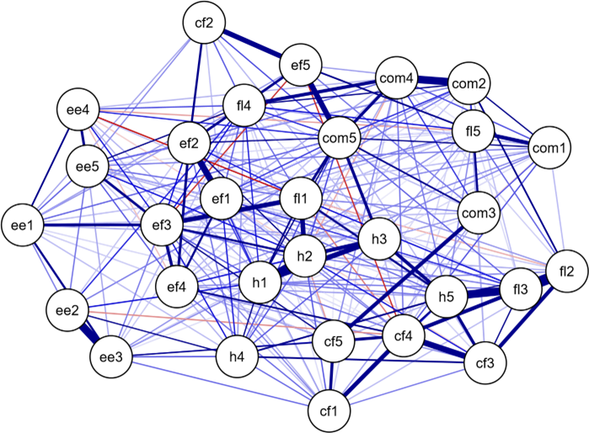
Note. The dark blue lines represent positive correlations while the red ones represent negative correlations. The edge thickness represents the strength of the association between the nodes.

Figure 2.
Centrality measures of the ESQ-RE items.
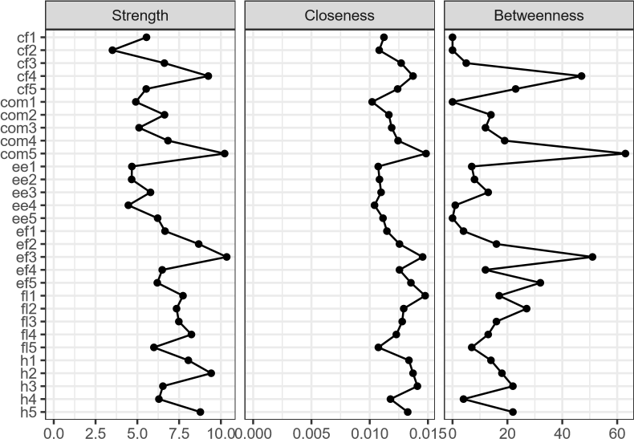
Note. The figure shows the standardized values for the strength, closeness, and betweenness of the ESQ-RE nodes.

Figure 3.
Community structure of the ESQ-RE containing 6 clusters.
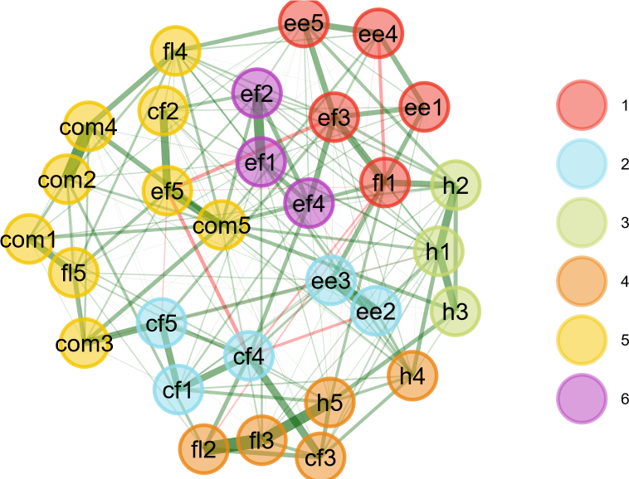
Note. Nodes starting with ‘h’ refers to housing, ‘ee’ to education and employment, ‘ef’ to economics and finances, ‘cf’ to child and family health, ‘fl’ to family life, and ‘com’ to community.

Address: Rua Marquês de São Vicente, 225, Gávea - Rio de Janeiro, RJ - Brasil - CEP: 22451-900 - Cx. Postal: 38097

